|  |  |
| --- | --- |
| Equation of the straight line | |
| y = **m x** + **c** | Or |
| $$ax+by+c=0$$ $$by = -ax+(-c)$$ $$y = \frac{-a}{b} x+\frac{-c}{b}$$ |  |

**m** OR $\frac{-a}{b}$ (Slope or Coefficient) = slope of the line

**c** OR $\frac{-c}{b}$ = Intercept (where the best-fit line meets the Y axis).

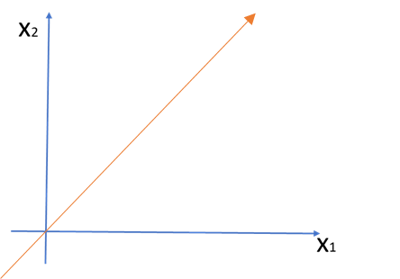

unit movement on the x-axis then what the movement on the y-axis is called slope?

a = is the x-intercept.

b = is the y-intercept.

For SVM we will use the below equation and calculate the m and c if a = 2 and b = 4 using the below equation.

|  |  |  |  |  |
| --- | --- | --- | --- | --- |
| ax + by + c = 0 | | | | |
| 2x + 4y + c = 0 | | | | |
| 4y = -2x + ( -c ) | | | | |
|  | y = | -2 | x + | -6 |
|  | -4 | -4 |
|  | y = | -1 | x + | -3 |
|  | -2 | -2 |
|  | y = | **0.5** | x + | **1.5** |
|  |

If we compare this equation with the “y = m x + c” equation, the value of **m = -0.5** and **c = 1.5**.

ax + by + c = 0

Above equation can be converted as below using the map.

$$ax_{2}+bx_{1}+c=0$$

If we consider a = $w_{2}$, b = $w_{1}$ then the above formula can be converted as below.

$$w_{2}x_{2}+w_{1}x_{1}+c=0$$ 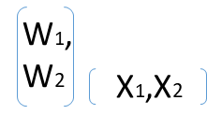 if we further simplify the equation it can be converted into matrix multiplication and hence the same can be converted as below.

$$W^{T}X+c=0$$

with regards to the below figure you will observe that a line that is passing through the origin will be the equation

wTx+c = 0

wTx+0 = 0

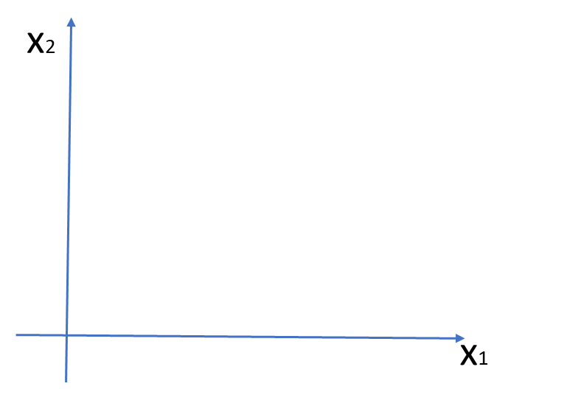

Hence below will be the equation that is passing through the origin.

wTx = 0

|  |
| --- |
| 2 Dimension |
| In two-dimensional data a straight line will be created which will separate the data. |

|  |
| --- |
| 3 Dimension |
| In “three” or “n” dimension data a hyperplane will be created which will separate the data as shown in the above image. |

Equation of a hyperplane:

The equation for Two-dimension

$$ax+by+c=0$$

In two-dimensional data, it is common practice to replace the conventional x and y axes with x1 and x2 for the sake of simplicity, as illustrated in the preceding graph. Similarly, and in three-dimensional data, we extend this approach by introducing x1, x2, and x3 as the respective axes, as depicted in the 2nd graph. For datasets with "n" dimensions, we consider the axes as x1, x2, x3, x4, ..., xn.

Hence for two-dimension, we can write the equation as below.

$$ax_{1}+bx_{2}+c =0$$

To simplify the equation further, it is often preferred to use w1 and w2 instead of “a” and “b”.

$$w_{1}x_{1}+w_{2}x_{2}+c =0$$

**The equation for Three Dimension**

The equation mentioned above can be extended to three dimensions as follows.

$$w_{1}x_{1}+w_{2}x_{2}+w_{3}x_{3}+ c =0$$

**The equation for a Dimension that is more than three.**

Similarly, for n-dimensions, the equation can be expressed as follows.

$$w_{1}x_{1}+w_{2}x_{2}+w_{3}x_{3} +w_{4}x_{4}… +w_{n}x_{n}+ c =0$$

To handle the majority of cases that involve n-dimensional data, it can be challenging to apply the existing equation directly. In order to improve usability, we can simplify the equation, as follows.

$$w^{T}x+ c =0$$

For better clarity in understanding SVC, we can assume that the hyperplane passes through the origin. With this assumption, hence if the hyperplane passes through the origin the value of “c” will be 0, resulting in the equation becoming as follows $(w^{T}x =0)$.

$$w^{T}x+ c =0$$

$$w^{T}x+ 0 =0$$

$$w^{T}x =0$$

The above equation is a generalized form that can be used for data in any dimensionality, including two-dimensional, three-dimensional, and even n-dimensional data. It offers flexibility and applicability across different dimensionalities.

By using the above equation we can create the **hyperplane in SVM.**

|  |  |
| --- | --- |
| Equation of the straight line | |
| y = **m x** + **c** | Or |
| y = **β0**+ **β1** **X1** | Or |
| hθ(x) = **θ0**+ **θ1** **X** | Or |
| ) |  |

**θ1** or **β1** or **m** OR (Slope or Coefficient) = if there is a

**θ0**or **β0**OR **c** OR = Intercept (where the best-fit line meets the Y axis).